**Project Design Phase-I Solution Architecture**

|  |  |
| --- | --- |
| **Date** | 27 September 2022 |
| **Team ID** | PNT2022TMID23730 |
| **Project Name** | Real-Time CommunicaGon System Powered by  AI for Specially Abled |
| **Maximum Marks** | 4 Marks |

Solution Architecture:

Image Dataset

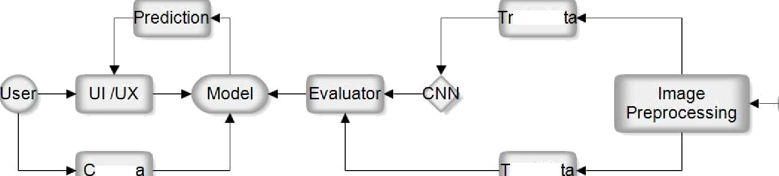

ain Da

amer

est Da